Assignment #___1__ Name: Tarun Banda

Program 1: MyFirstProgram.java

**Screenshot (Sample Run) :**

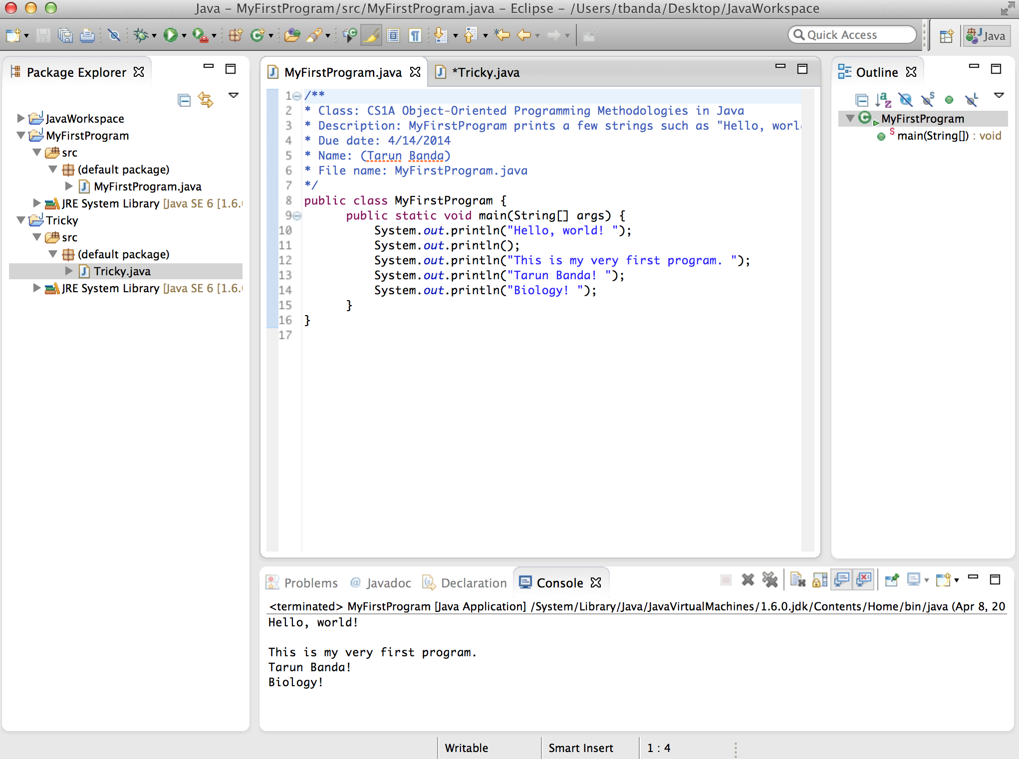

Program 2: Tricky.java

**Screenshot (Sample Run):**

